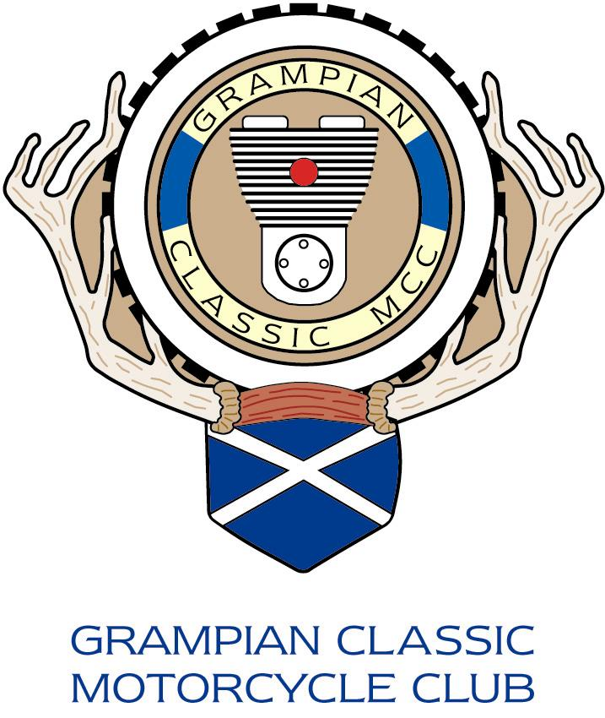

MEMBERSHIP APPLICATION TO JOIN THE GRAMPIAN CLASSIC MOTORCYCLE CLUB

www.gcmcc.co.uk

Note – If you have a current e-mail address, please write it clearly on the form below, it helps us reduce postage costs. Thank you.

_________________________________________________________________________________________

GRAMPIAN CLASSIC MOTORCYCLE CLUB
APPLICATION TO JOIN FOR 2023/24

The membership fee for 2023/24 will be £15-00 and the membership will run to 31.10.2024. To join the club, please complete this form and return it promptly with payment by PayPal or a cheque for £15 made out to “GRAMPIAN CLASSIC MCC” to Maurice Clarke 7, Benview Gardens, Oldmeldrum, Aberdeenshire, AB51 0FY (Telephone 01651 873034).

Cheques should be made payable to the Grampian Classic M.C.C.

Name________________ Address_________________________________________________________________

___________________________________________________________________________________________________

Telephone _____________________________________ Mobile ________________________

E-Mail _____________________________________________________ VMCC - I am a member of the VMCC Yes / No

I agree to my email address and Mobile number being communicated only to other members of the GCMCC Yes / No
I would like my mobile number included in the GCMCC WHATSAPP group Yes / No

Bike(s) Owned ______________________________________________________________________________________

This form can also be completed and emailed to mauriceiclarke@btinternet.com and payment can be made electronically using PayPal by sending your membership fee to treasurer@gcmcc.co.uk quoting your name as the reference. Please indicate you are sending money to a friend during the Paypal payment process.

NOTE – The club caters for all those with an interest in classic motorcycles. We meet monthly on the first Tuesday at the Royal British Legion in Oldmeldrum. We have evening runs from May to September, club nights in the other months, social events and occasional weekend runs, including our flagship event in mid May, the annual Cairn O’ Mount.

